3-amaliy mashg‘ulot.
Matlab dasturida davriy diskret signallarni o’rganish.

Ishning maqsadi: Talabalarga davriy diskret signallar tushunchasini, ularning parametrlarini va Matlab muhitida dasturlash orqali vizual tahlil qilishni o‘rgatish
Nazariy qism:
Diskret signal – vaqt bo‘yicha diskretlangan, ya’ni ma’lum oraliqlarda o‘lchanadigan signal.
Davriy signal – agar signalning qiymati ma’lum davrdan keyin takrorlansa, u holda signal davriy deyiladi:
x[n]=x[n+N],N∈Z
Bu yerda N – signal davri.
- Misol:
  - Diskret sinusoidal signal:
x[n]=A⋅sin(ω₀n+φ)
Bu yerda:
  - A – amplituda,
  - ω₀​ – burchak chastotasi,
  - φ – faza siljishi.

Topshiriq variantlari:
1. Faza siljishini ko‘rsatish
Fazasi turlicha bo‘lgan ikkita signalni qurib taqqoslang.

% Parametrlar
A = 1;
f = 2;
Fs = 50;
t = 0:1/Fs:1;

% Fazali signallar
x1 = A * sin(2*pi*f*t);
x2 = A * sin(2*pi*f*t + pi);
y = x1+x2;

% Grafik
stem(t, x1, 'b', 'filled'); hold on;
stem(t, x2, 'r', 'filled'); hold on;
stem(t, y, 'g', 'filled');
title('Fazasi turlicha bolgan sinusoidal signallar');
xlabel('n');
ylabel('x[n]');
legend('phi = 0', 'phi = \pi');
grid on;

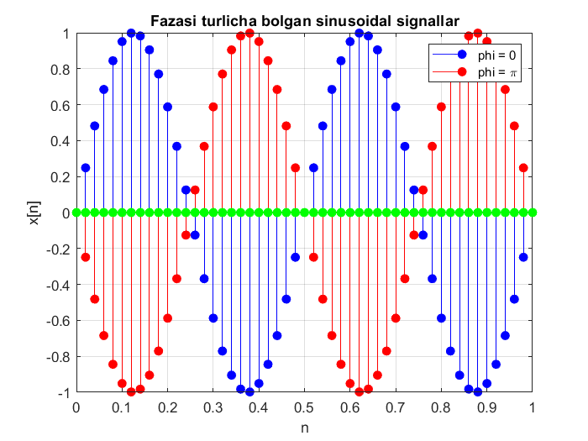

2. Variant 2:
Bir nechta davriy signallar kombinatsiyasi
Ikkita davriy signal yig‘indisini hosil qiling:
x[n]=sin(2πf₁n)+0.5⋅cos(2πf₂n)
% Parametrlar
Fs = 500;
t = 0:1/Fs:1;

f1 = 2;
f2 = 7;

x = sin(2*pi*f1*t);
y = 0.5*cos(2*pi*f2*t);
z = x+y;

% Grafik
stem(t, x, 'b', 'filled'); hold on;
stem(t, y, 'r', 'filled');
stem(t, z, 'g', 'filled');
title('Bir nechta davriy signallar yigindisi');
xlabel('n');
ylabel('x[n]');
grid on;
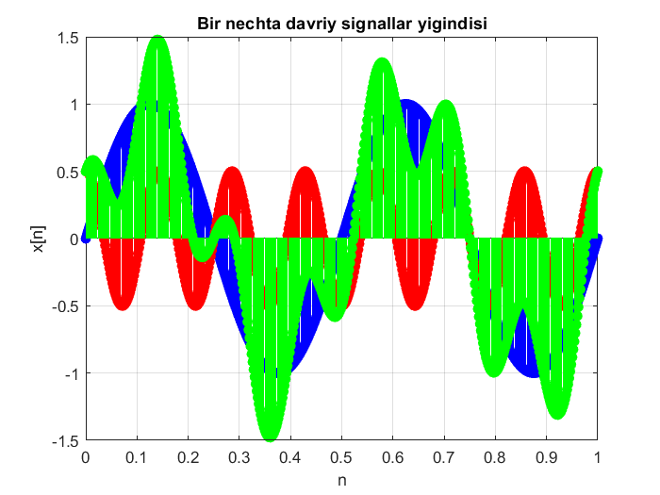
Topshiriq:
- Fazasi turlicha bo‘lgan ikkita signalni qurib taqqoslang.
№ | F | φ | № | F | φ
1 | 10 | π/8 | 11 | 30 | π/8
2 | 15 | π/6 | 12 | 40 | π/6
3 | 20 | π/4 | 13 | 50 | π/4
4 | 25 | π/2 | 14 | 10 | π/2
5 | 30 | π | 15 | 15 | π
6 | 40 | π/8 | 16 | 20 | π/8
7 | 50 | π/6 | 17 | 25 | π/6
8 | 10 | π/4 | 18 | 30 | π/4
9 | 15 | π/2 | 19 | 40 | π/2
10 | 20 | π | 20 | 50 | π

- Ikkita davriy signal yig‘indisini hosil qiling:
№ | F1 | F2 | A1 | A2 | № | F1 | F2 | A1 | A2
1 | 10 | 15 | 1 | 0.5 | 11 | 30 | 15 | 1.5 | 1.5
2 | 15 | 25 | 1.5 | 1 | 12 | 40 | 25 | 2 | 2
3 | 20 | 35 | 2 | 1.5 | 13 | 50 | 35 | 1 | 0.5
4 | 25 | 45 | 1 | 2 | 14 | 10 | 45 | 1.5 | 1
5 | 30 | 60 | 1.5 | 0.5 | 15 | 15 | 60 | 2 | 1.5
6 | 40 | 15 | 2 | 1 | 16 | 20 | 15 | 1 | 2
7 | 50 | 25 | 1 | 1.5 | 17 | 25 | 25 | 1.5 | 0.5
8 | 10 | 35 | 1.5 | 2 | 18 | 30 | 35 | 2 | 1
9 | 15 | 45 | 2 | 0.5 | 19 | 40 | 45 | 1 | 1.5
10 | 20 | 60 | 1 | 1 | 20 | 50 | 60 | 1.5 | 2

